**Práctica 3 – Diseño Electrónico**

**Evidencias de Funcionamiento**

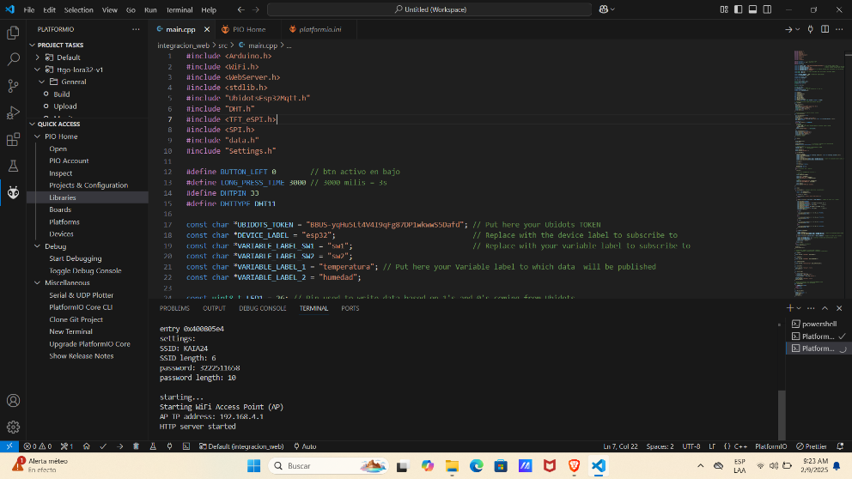

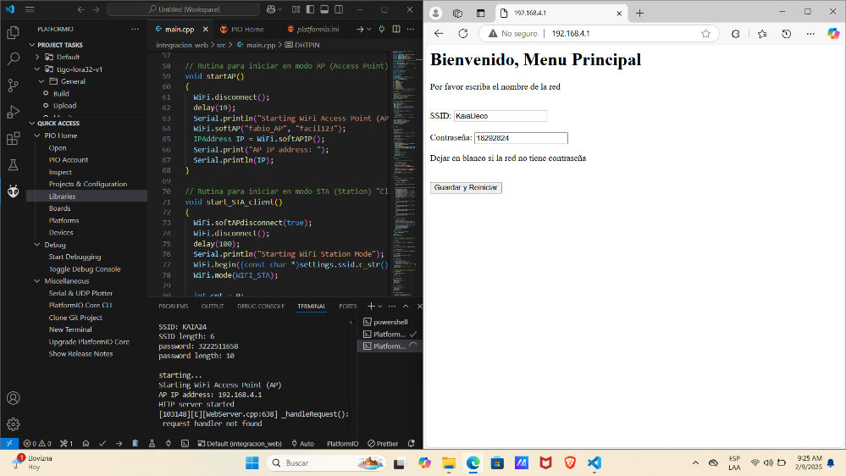

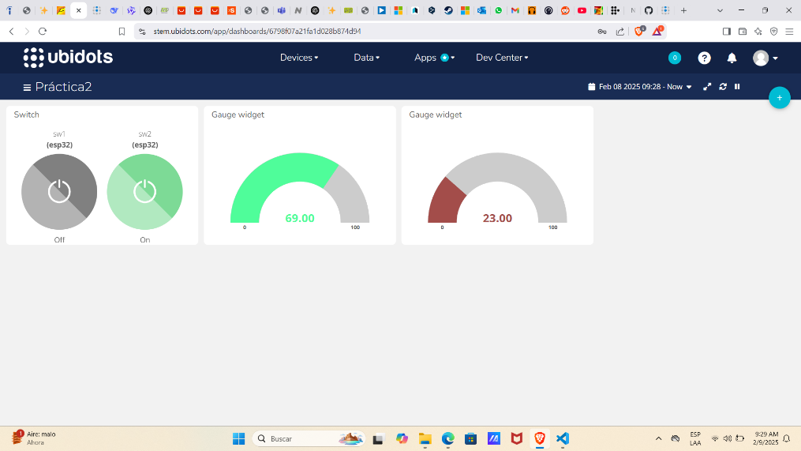

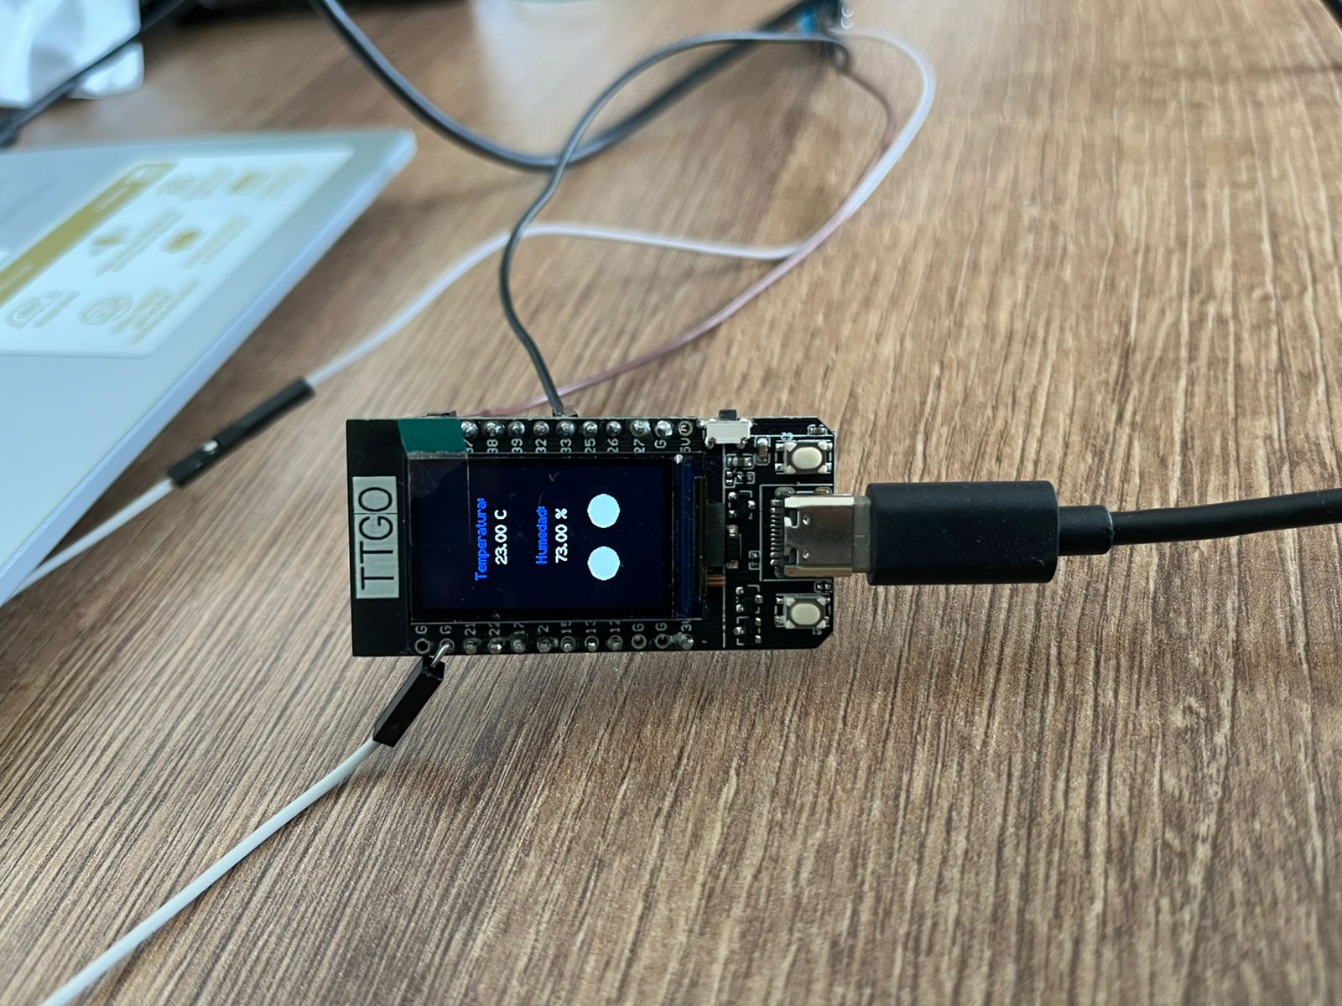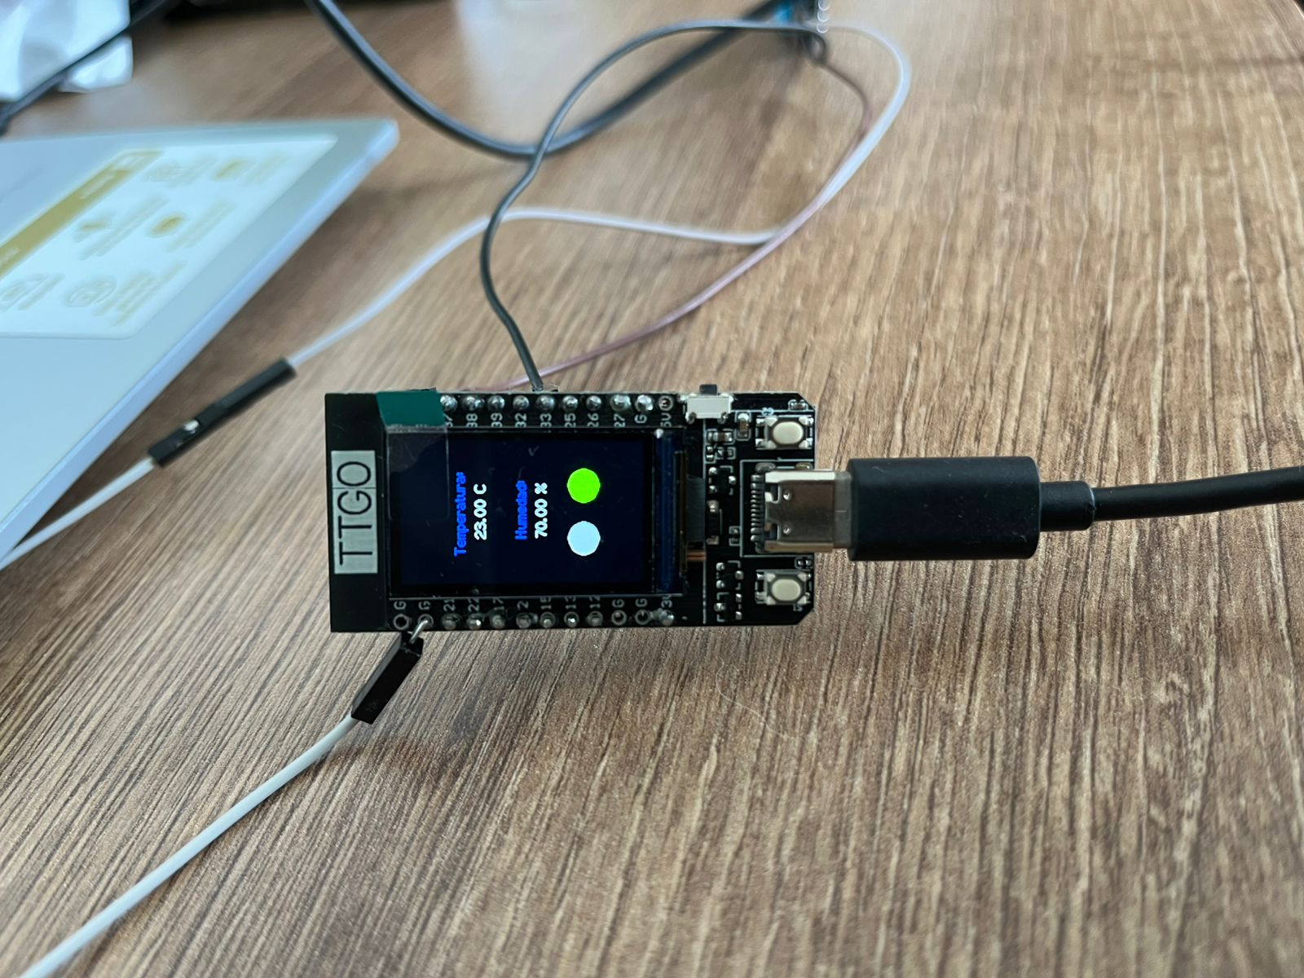

**Código**

#include <Arduino.h>

#include <WiFi.h>

#include <WebServer.h>

#include <stdlib.h>

#include "UbidotsEsp32Mqtt.h"

#include "DHT.h"

#include <TFT_eSPI.h>

#include <SPI.h>

#include "data.h"

#include "Settings.h"

#define BUTTON_LEFT 0        // btn activo en bajo

#define LONG_PRESS_TIME 3000 // 3000 milis = 3s

#define DHTPIN 33

#define DHTTYPE DHT11

const char *UBIDOTS_TOKEN = "BBUS-yqHu5Lt4V4I9qFg87DP1wkwwS5Dafd"; // Put here your Ubidots TOKEN

const char *DEVICE_LABEL = "esp32";                                // Replace with the device label to subscribe to

const char *VARIABLE_LABEL_SW1 = "sw1";                            // Replace with your variable label to subscribe to

const char *VARIABLE_LABEL_SW2 = "sw2";

const char *VARIABLE_LABEL_1 = "temperatura"; // Put here your Variable label to which data  will be published

const char *VARIABLE_LABEL_2 = "humedad";

const uint8_t LED1 = 26; // Pin used to write data based on 1's and 0's coming from Ubidots

const uint8_t LED2 = 25;

const int PUBLISH_FREQUENCY = 5000; // Update rate in milliseconds

const int OLED_FREQUENCY = 1000;

unsigned long publish_timer;

unsigned long oled_timer;

bool sw1, sw2 = false;

Ubidots ubidots(UBIDOTS_TOKEN);

TFT_eSPI tft = TFT_eSPI();

DHT dht(DHTPIN, DHTTYPE);

WebServer server(80);

Settings settings;

int lastState = LOW; // para el btn

int currentState;    // the current reading from the input pin

unsigned long pressedTime = 0;

unsigned long releasedTime = 0;

void load404();

void loadIndex();

void loadFunctionsJS();

void restartESP();

void saveSettings();

bool is_STA_mode();

void AP_mode_onRst();

void STA_mode_onRst();

void detect_long_press();

void callback(char *topic, byte *payload, unsigned int length);

// Rutina para iniciar en modo AP (Access Point) "Servidor"

void startAP()

{

  WiFi.disconnect();

  delay(19);

  Serial.println("Starting WiFi Access Point (AP)");

  WiFi.softAP("fabio_AP", "facil123");

  IPAddress IP = WiFi.softAPIP();

  Serial.print("AP IP address: ");

  Serial.println(IP);

}

// Rutina para iniciar en modo STA (Station) "Cliente"

void start_STA_client()

{

  WiFi.softAPdisconnect(true);

  WiFi.disconnect();

  delay(100);

  Serial.println("Starting WiFi Station Mode");

  WiFi.begin((const char *)settings.ssid.c_str(), (const char *)settings.password.c_str());

  WiFi.mode(WIFI_STA);

  int cnt = 0;

  while (WiFi.status() != WL_CONNECTED)

  {

    delay(500);

    // Serial.print(".");

    if (cnt == 100) // Si después de 100 intentos no se conecta, vuelve a modo AP

      AP_mode_onRst();

    cnt++;

    Serial.println("attempt # " + (String)cnt);

  }

  WiFi.setAutoReconnect(true);

  Serial.println(F("WiFi connected"));

  Serial.println(F("IP address: "));

  Serial.println(WiFi.localIP());

  pressedTime = millis();

  // Rutinas de Ubidots

}

void setup()

{

  Serial.begin(115200);

  delay(2000);

  EEPROM.begin(4096);                 // Se inicializa la EEPROM con su tamaño max 4KB

  pinMode(BUTTON_LEFT, INPUT_PULLUP); // btn activo en bajo

  // settings.reset();

  settings.load(); // se carga SSID y PWD guardados en EEPROM

  settings.info(); // ... y se visualizan

  Serial.println("");

  Serial.println("starting...");

  if (is_STA_mode())

  {

    start_STA_client();

    ubidots.connectToWifi((const char *)settings.ssid.c_str(), (const char *)settings.password.c_str());

    ubidots.setCallback(callback);

    ubidots.setup();

    ubidots.reconnect();

    ubidots.subscribeLastValue(DEVICE_LABEL, VARIABLE_LABEL_SW1); // Insert the device and variable's Labels, respectively

    ubidots.subscribeLastValue(DEVICE_LABEL, VARIABLE_LABEL_SW2);

    dht.begin();

    tft.init();

    tft.fillScreen(TFT_BLACK);

    pinMode(LED1, OUTPUT);

    pinMode(LED2, OUTPUT);

  }

  else // Modo Access Point & WebServer

  {

    startAP();

    /* ========== Modo Web Server ========== */

    /* HTML sites */

    server.onNotFound(load404);

    server.on("/", loadIndex);

    server.on("/index.html", loadIndex);

    server.on("/functions.js", loadFunctionsJS);

    /* JSON */

    server.on("/settingsSave.json", saveSettings);

    server.on("/restartESP.json", restartESP);

    server.begin();

    Serial.println("HTTP server started");

  }

}

void loop()

{

  if (is_STA_mode()) // Rutina para modo Station (cliente Ubidots)

  {

    float h = dht.readHumidity();

    float t = dht.readTemperature();

    if (isnan(h) || isnan(t))

    {

      Serial.println(F("Failed to read from DHT sensor!"));

      return;

    }

    if (abs((int)(millis() - oled_timer)) > OLED_FREQUENCY) // triggers the routine every 5 seconds

    {

      tft.fillScreen(TFT_BLACK);

      tft.setTextColor(TFT_BLUE);

      tft.drawString("Temperatura: ", tft.width() / 2 - 5 * 8, 50, 2);

      tft.setTextColor(TFT_WHITE);

      tft.drawString(String(t) + " C", tft.width() / 2 - 3 * 8, 70, 2);

      tft.setTextColor(TFT_BLUE);

      tft.drawString("Humedad: ", tft.width() / 2 - 3 * 8, 110, 2);

      tft.setTextColor(TFT_WHITE);

      tft.drawString(String(h) + " %", tft.width() / 2 - 3 * 8, 130, 2);

      oled_timer = millis();

      if (sw1)

      {

        tft.fillCircle(tft.width() / 2 - 25, 180, 15, TFT_GREEN);

        digitalWrite(LED1, HIGH);

      }

      else

      {

        tft.fillCircle(tft.width() / 2 - 25, 180, 15, TFT_SILVER);

        digitalWrite(LED1, LOW);

      }

      if (sw2)

      {

        tft.fillCircle(tft.width() / 2 + 25, 180, 15, TFT_GREEN);

        digitalWrite(LED2, HIGH);

      }

      else

      {

        tft.fillCircle(tft.width() / 2 + 25, 180, 15, TFT_SILVER);

        digitalWrite(LED2, LOW);

      }

    }

    if (!ubidots.connected())

    {

      ubidots.reconnect();

      ubidots.subscribeLastValue(DEVICE_LABEL, VARIABLE_LABEL_SW1); // Insert the device and variable's Labels, respectively

      ubidots.subscribeLastValue(DEVICE_LABEL, VARIABLE_LABEL_SW2);

    }

    if (abs((int)(millis() - publish_timer)) > PUBLISH_FREQUENCY) // triggers the routine every 5 seconds

    {

      ubidots.add(VARIABLE_LABEL_1, t); // Insert your variable Labels and the value to be sent

      ubidots.add(VARIABLE_LABEL_2, h);

      ubidots.publish(DEVICE_LABEL);

      publish_timer = millis();

    }

    ubidots.loop();

  }

  else // rutina para AP + WebServer

    server.handleClient();

  delay(10);

  detect_long_press();

}

// funciones para responder al cliente desde el webserver:

// load404(), loadIndex(), loadFunctionsJS(), restartESP(), saveSettings()

void load404()

{

  server.send(200, "text/html", data_get404());

}

void loadIndex()

{

  server.send(200, "text/html", data_getIndexHTML());

}

void loadFunctionsJS()

{

  server.send(200, "text/javascript", data_getFunctionsJS());

}

void restartESP()

{

  server.send(200, "text/json", "true");

  ESP.restart();

}

void saveSettings()

{

  if (server.hasArg("ssid"))

    settings.ssid = server.arg("ssid");

  if (server.hasArg("password"))

    settings.password = server.arg("password");

  settings.save();

  server.send(200, "text/json", "true");

  STA_mode_onRst();

}

// Rutina para verificar si ya se guardó SSID y PWD del cliente

// is_STA_mode retorna true si ya se guardaron

bool is_STA_mode()

{

  if (EEPROM.read(flagAdr))

    return true;

  else

    return false;

}

void AP_mode_onRst()

{

  EEPROM.write(flagAdr, 0);

  EEPROM.commit();

  delay(100);

  ESP.restart();

}

void STA_mode_onRst()

{

  EEPROM.write(flagAdr, 1);

  EEPROM.commit();

  delay(100);

  ESP.restart();

}

void detect_long_press()

{

  // read the state of the switch/button:

  currentState = digitalRead(BUTTON_LEFT);

  if (lastState == HIGH && currentState == LOW) // button is pressed

    pressedTime = millis();

  else if (lastState == LOW && currentState == HIGH)

  { // button is released

    releasedTime = millis();

    // Serial.println("releasedtime" + (String)releasedTime);

    // Serial.println("pressedtime" + (String)pressedTime);

    long pressDuration = releasedTime - pressedTime;

    if (pressDuration > LONG_PRESS_TIME)

    {

      Serial.println("(Hard reset) returning to AP mode");

      delay(500);

      AP_mode_onRst();

    }

  }

  // save the the last state

  lastState = currentState;

}

void callback(char *topic, byte *payload, unsigned int length)

{

  if (strstr(topic, "sw1") != NULL)

  {

    if ((char)payload[0] == '1')

    {

      sw1 = true;

    }

    else

    {

      sw1 = false;

    }

  }

  if (strstr(topic, "sw2") != NULL)

  {

    if ((char)payload[0] == '1')

    {

      sw2 = true;

    }

    else

    {

      sw2 = false;

    }

  }

}